**BOOT UP WITH SD CARD**

# Data to boot.

* Device tree (dtb file).
* Image.
* Rootfs.

# Prepare SD card.

1. Switch to write mode on the SD card.
2. Install Virtual machine or using Linux device.
3. Select SD card on virtual box.

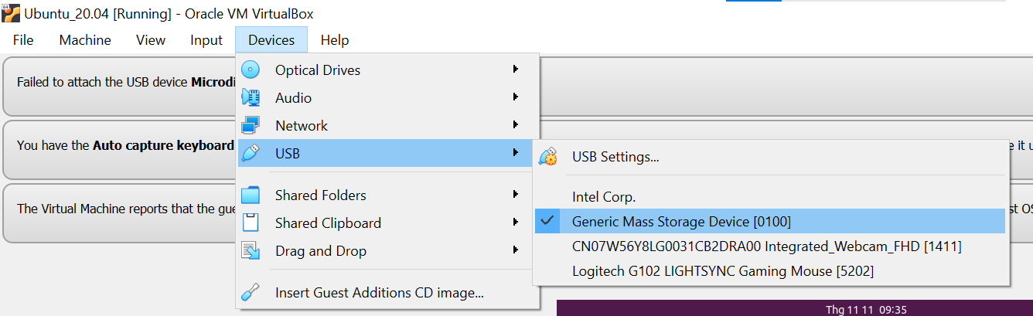

* I use USB to read so device name may be different. Check your device name.

1. Copy file from Linux to SD card:

* List devices:

$ lsblk

* Create a folder to mount SD card:

$ sudo mkdir -p /media/data

* Mount /dev/sdb1 to /media/data

$ sudo mount /dev/sdb1 /media/data

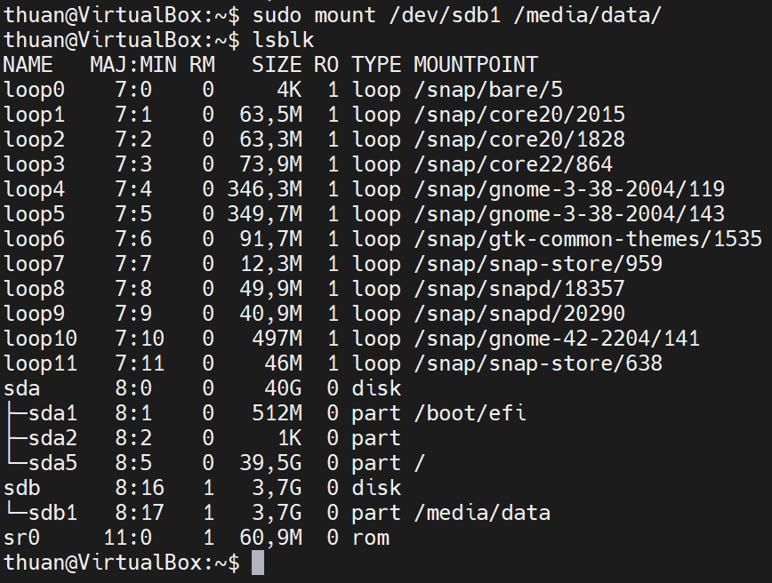

* Use scp to copy file from lab to SD card:

$ sudo scp [<username>@<IP_lab>:</path/to/data](mailto:thuan.ha-nhu@192.168.2.25:/path/to/data)> media/data/





* Sync data before umount (Important):

$ sync

1. Remove SD card and use for booting board.

# Setup U-Boot.

* Check and set boot environment with following command:

**$ setenv bootargs_sd0 'rw root=/dev/mmcblk1p1 rootwait'**

**$ setenv booti_cmd 'booti 0x48080000 - 0x48000000'**

**$ setenv dtb 'r8a77961-salvator-xs.dtb'**

**$ setenv bootcmd_sd0 'setenv bootargs ${bootargs_sd0};ext2load mmc 0:1 0x48080000 /boot/Image;ext2load mmc 0:1 0x48000000 /boot/${dtb};run booti_cmd'**

**$ setenv bootcmd 'run bootcmd_sd0'**

* Save environment setup:

**$ savee**

* Boot up board with command:

**$ run bootcmd**